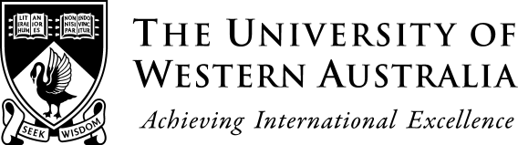
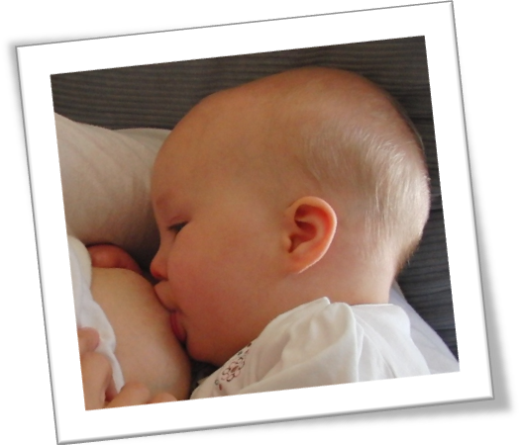
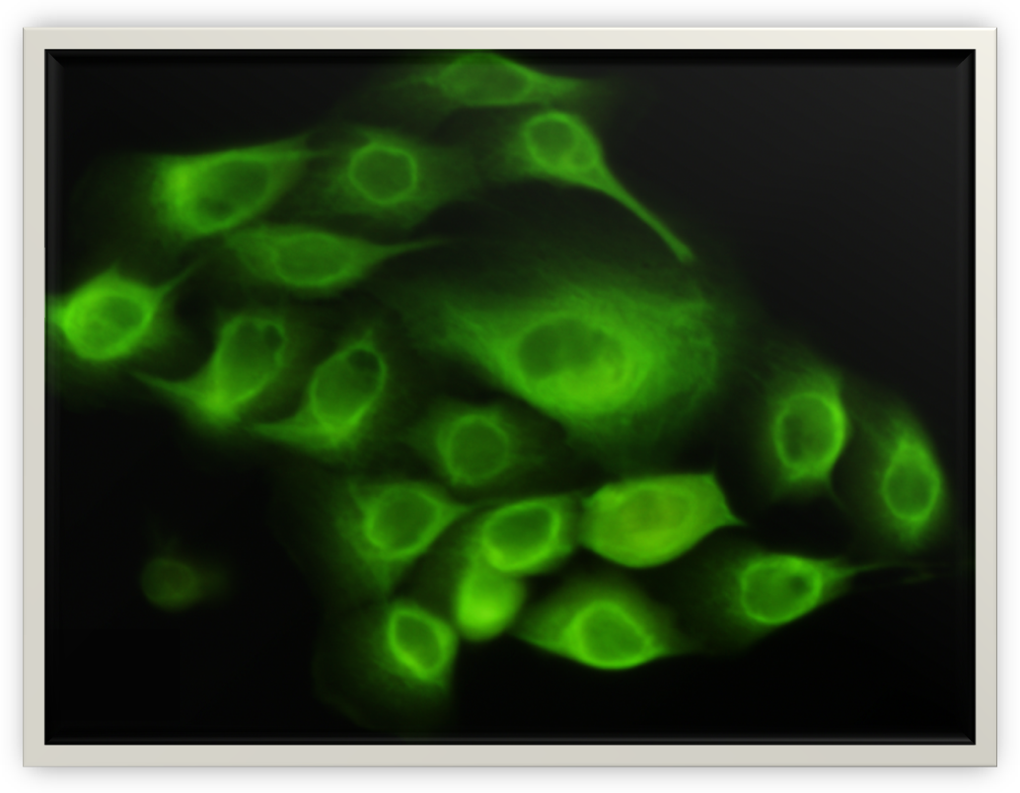
Hartmann Human Lactation Research Group
School of Chemistry and Biochemistry
The University of Western Australia
M310, Crawley WA 6009 Australia
CRICOS Provider Code: 00126G

Are you Breastfeeding and/or Expressing Breastmilk?
You may consider participating in one of our studies

The Hartmann Human Lactation Research Group is looking for participating lactating mothers for the following research studies:

THE CELLULAR COMPOSITION OF HUMAN MILK – STEM CELLS AND IMMUNE CELLS

This study examines the properties and role of breastmilk stem cells and immune cells. It looks at potential benefits for the infant, how these cells assist in the normal function of the lactating breast, and whether they can be used as diagnostic tools for pathologies of the lactating breast, such as mastitis. Recruitment is ongoing, for any lactation stage. Participants will provide small volumes of breastmilk and can be recruited during either lactation or pregnancy, via expression of interest, and will:
- Be healthy; or
- Have mastitis, blocked duct, nipple pain, or other infection; or
- Have type I diabetes; or
- Have delivered (or expect to deliver) preterm, and are able to participate within 2 weeks postpartum

For more information please contact Dr Foteini Hassiotou (foteini.hassiotou@uwa.edu.au, 0433 528 943)

BREASTMILK AND INFANT BODY COMPOSITION

It is known that breastfeeding reduces the chance of obesity later in the infant’s life, however it is not known how or why. This study aims to measure appetite control hormones in the milk as well as examine breastfeeding patterns and gastric emptying to determine how they impact infant body composition. Currently we are recruiting 4 groups of 10 mothers and babies between 6 and 10 weeks, 4.5-5.5 months, 8.5-9.5 months and 11.5 to 12.5 months. At a visit to our labs at King Edward Hospital we will:
- measure infant body composition – this is non-invasive
- take some small milk samples before and after feeding
- scan the baby’s stomach with ultrasound before the feed and at 20 minute intervals until the next feed

For more information please contact Dr Donna Geddes (donna.geddes@uwa.edu.au, 0415 419 881)

MEASUREMENT OF BREASTMILK PRODUCTION

We currently measure breastmilk production by asking the mother to weigh her baby before and after all breastfeeds at home for 24 hours. We aim to assess if a preferable alternative would be pump the breast(s) with an electric breast pump for 10 minutes every hour for 3 hours (4 pumps). The pumping will take place in the research room at The University of Western Australia and mothers will be able to keep the expressed milk. We are recruiting mothers who have previously expressed milk and whose babies will take breastmilk from a bottle.

For more information please contact Dr Jacqueline Kent (Jacqueline.Kent@uwa.edu.au, 0421 963 437)

METABOLITE PROFILING OF HUMAN MILK IN MOTHERS WITH NIPPLE PAIN

Nipple pain is largely responsible for early weaning of infants, whereas exclusive breastfeeding for 6 months is preferred. I’m conducting a study on metabolites present in milk at the time of nipple pain. Participants will be asked to donate 15ml of milk, which will be tested for compositional changes. Milk can be expressed at The University of Western Australia or home collection can be organised if that is more suitable. The results will enable us to identify changes in milk composition allowing us to gain a greater understanding into the cause and effect of nipple pain.

For more information please contact Erin Fee (erin.fee1@my.nd.edu.au, 0431 190 741 )

